**ASSIGNMENT DATE-04-01-2024**

FIRST ETL WORKLOADS ON AZURE DATABRICKS:

Setting up an ETL (Extract, Transform, Load) workload on Azure Databricks involves several steps. Here's a simplified guide to help you get started. Note that you need an Azure subscription and access to Azure Databricks.

1. **Set up an Azure Databricks Workspace:**
   * Go to the Azure Portal (<https://portal.azure.com/>).
   * Create a new Databricks workspace.
   * Follow the wizard to configure your workspace.
2. **Create a Databricks Cluster:**
   * In the Databricks workspace, navigate to the Clusters page.
   * Create a new cluster by providing the necessary configurations (e.g., cluster name, instance type, and number of worker nodes).
3. **Create a Databricks Notebook:**
   * Go to the Databricks workspace and create a new notebook.
   * Choose the default language (e.g., Python or Scala) based on your preference.
4. **Write ETL Code:**
5. **Run the Notebook:**
   * Execute the notebook to run your ETL code.
   * You can monitor the job progress and view the results in the notebook.
6. **Data Storage and Integration:**
   * Ensure that your source and destination paths point to the correct data storage locations (e.g., Azure Data Lake Storage, Azure Blob Storage).
   * Consider integrating with other Azure services for advanced features (e.g., Azure Data Factory for orchestration).
7. **Schedule ETL Job (Optional):**
   * If you want to schedule the ETL job to run at specific intervals, you can set up a Databricks Job.

That's a basic outline of running an ETL workload on Azure Databricks. Remember to adapt the code and configurations based on your specific requirements and data sources.

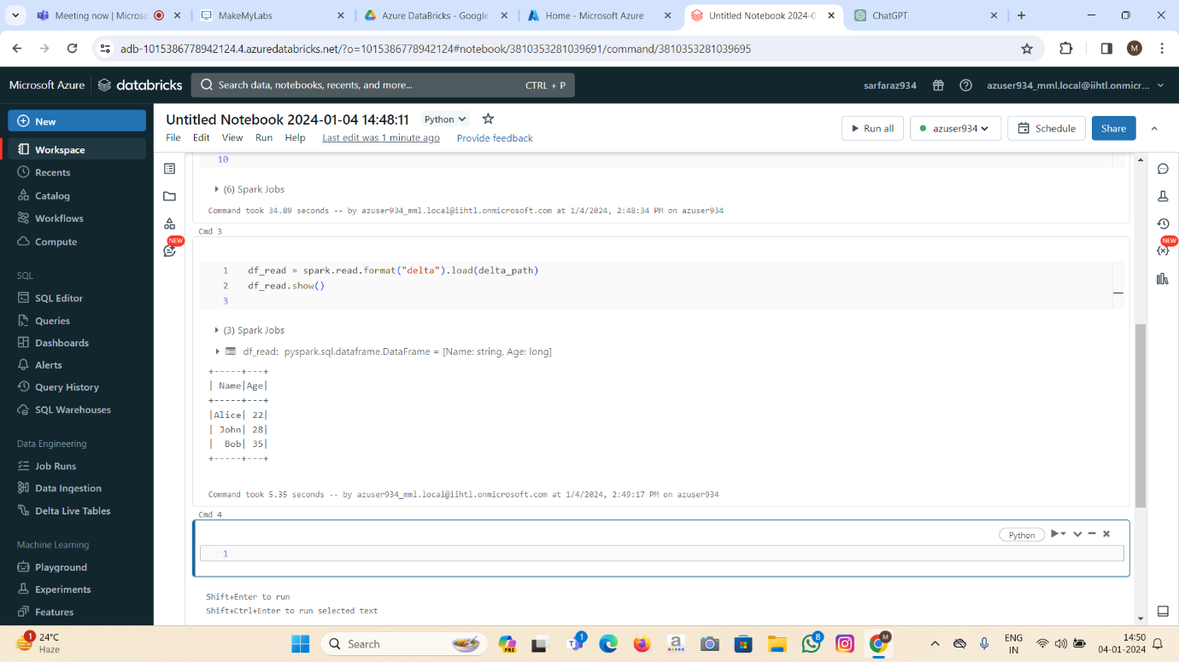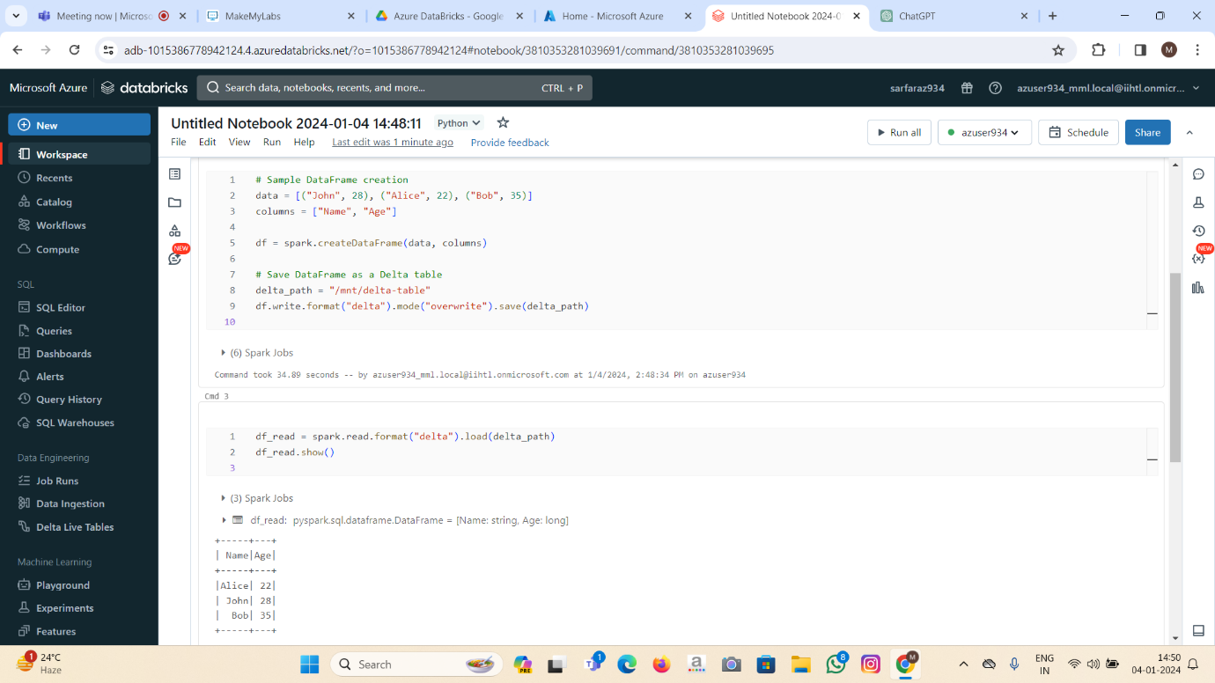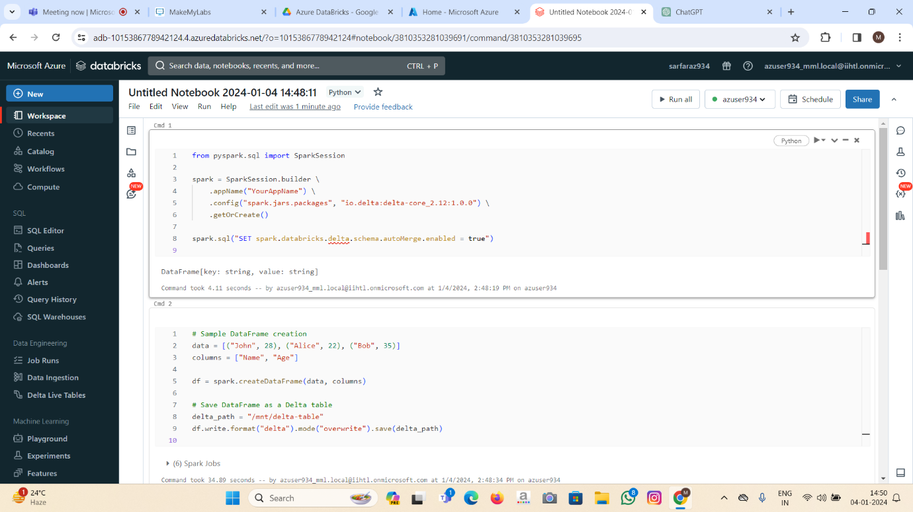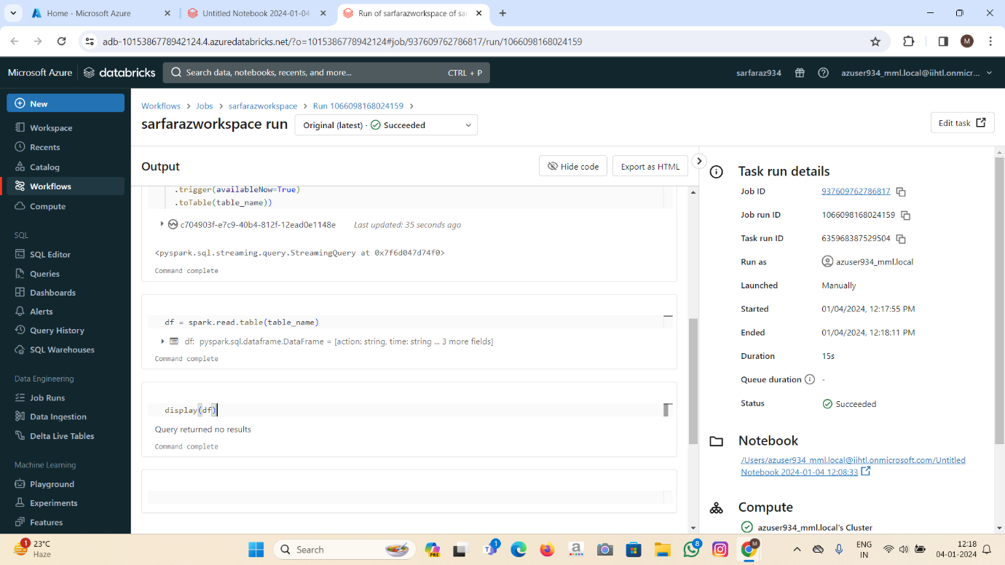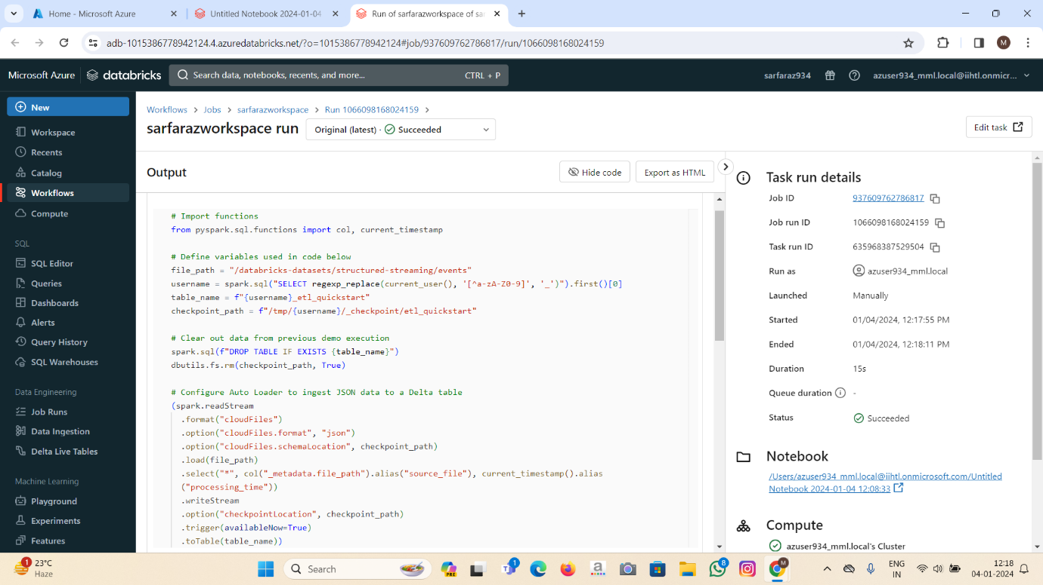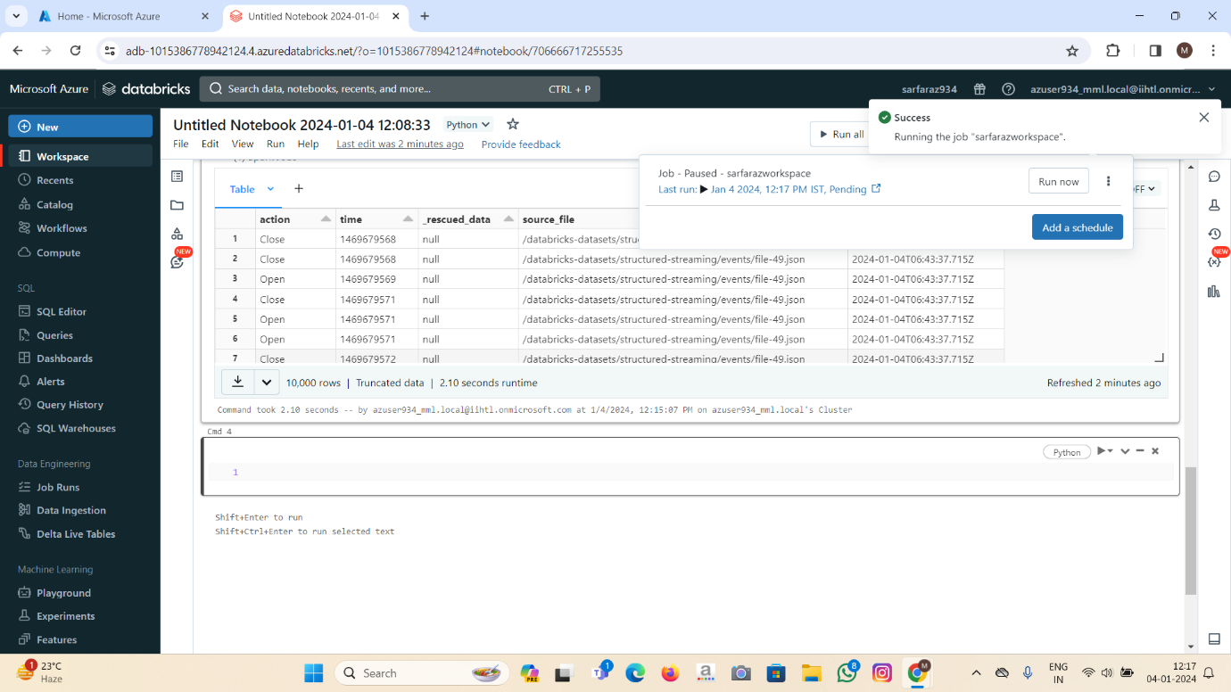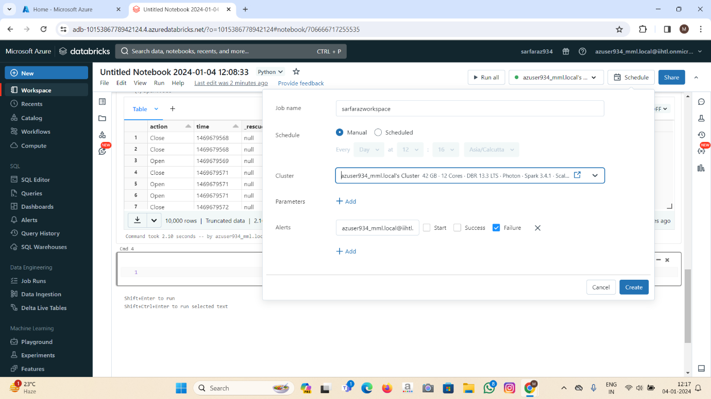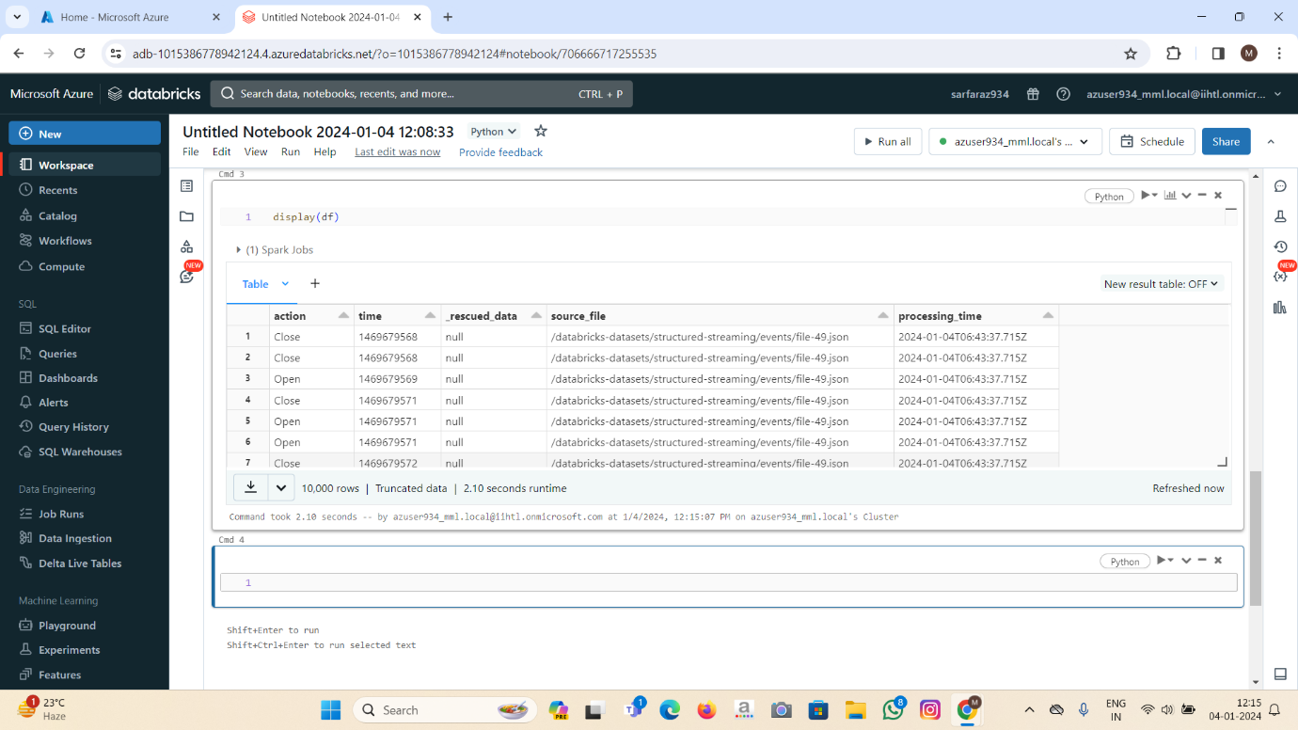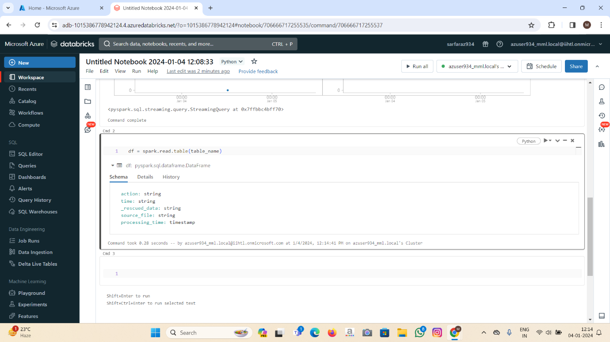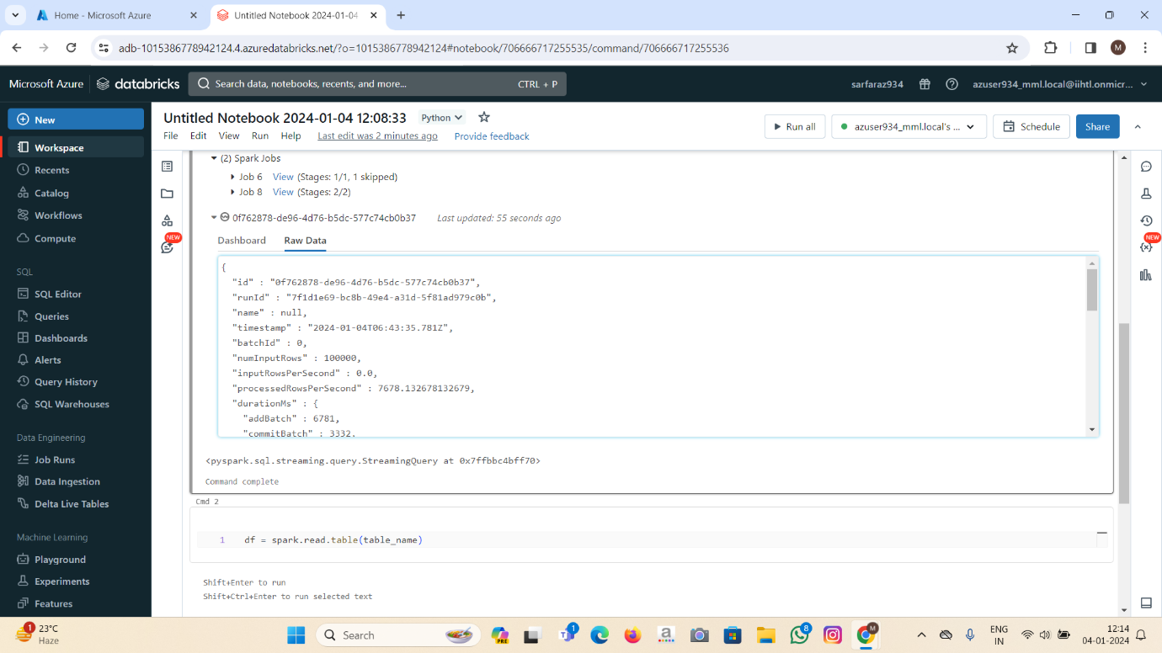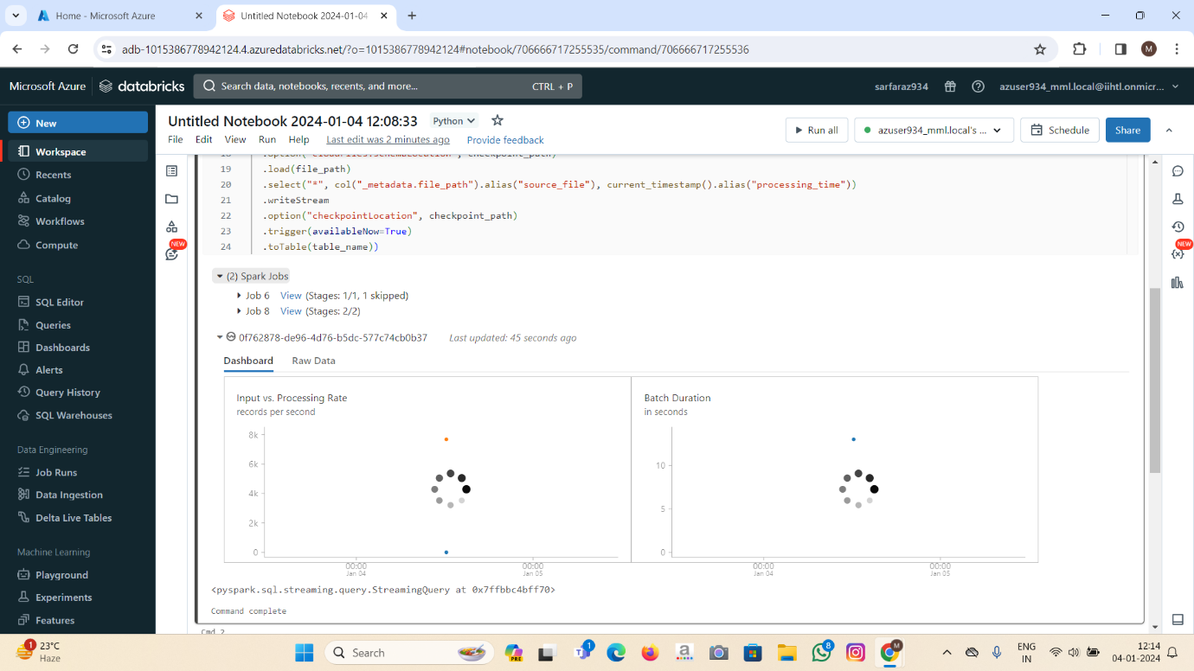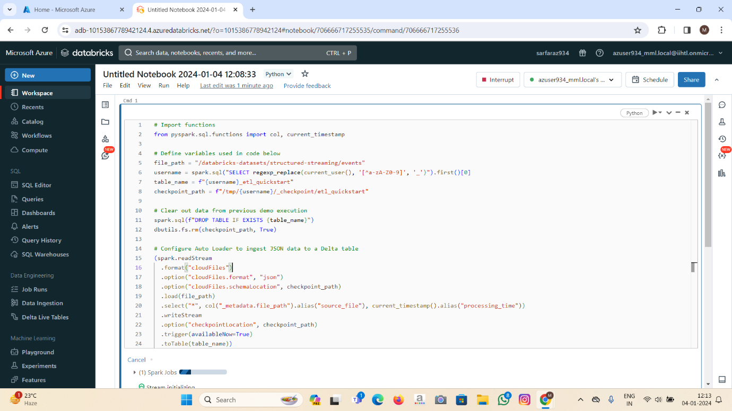S